- Added New JS Files

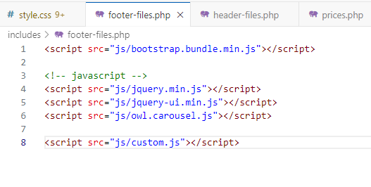
- Added Google Fonts Files

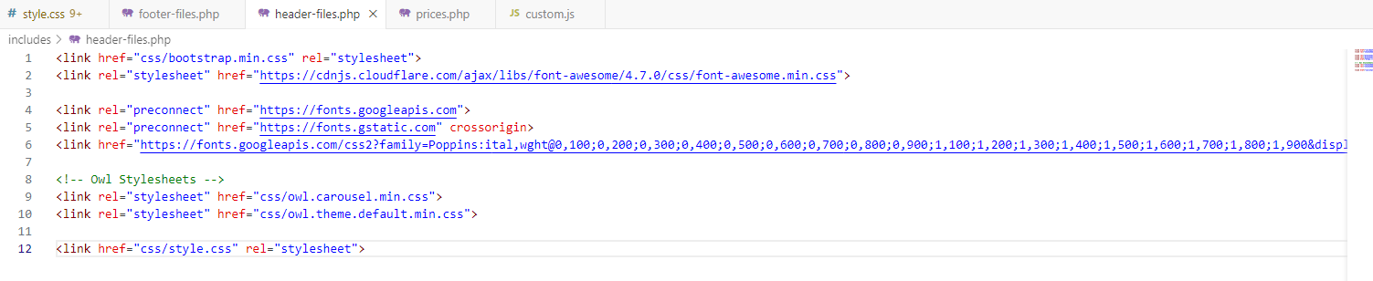

- Completed Order page (Kindly use fresh HTML)

- Kindly Replace these Files
- index.php
- css/style.css
- js/custom.js

