Term Project Paper
SP24 – BUS441 – Business in Society
Amazon Inc.
Professor John Crenshaw
27/04/2024

Table of Contents
- PROBLEM IDENTIFICATION AND DESCRIPTION 1
- Problem Statement 3
- Impact on the Organization 3
- Affected Stakeholders 3
- Potential Root Causes 4
- Parties Working on the Problem 4
- Duration of Efforts 5
- PROBLEM ANALYSIS 5
- Data Gathering Steps 5
- Analysis Tools 6
- Facilitating Solution Determination 6
- PROBLEM RESOLUTION 7
- Recommended Solution and Expected Result 7
- Implementation Monitoring and Management 8
- Implementation Timeline 9
- Risks and Mitigation Strategies 9
- Verifying Effectiveness 10
REFERENCES 11
APPENDIX I 12
APPENDIX II 13
APPENDIX III 14

- PROBLEM IDENTIFICATION AND DESCRIPTION
- Problem Statement
⁠In its extensive fulfilment centers, Amazon has been accused of having substandard working conditions, low wages, and breaches of labour rights. Despite its significant global influence, the company has faced scrutiny for favoring productivity and efficiency at the expense of its warehouse staff's welfare and equitable treatment (Tadepalli & Tadepalli, 2023). Serious concerns have been raised about the long working hours, unrealistic productivity targets, and restricted breaks that Amazon employees endure (Palmer, 2023). This matter is of great importance to me as it impacts the welfare and rights of many workers within Amazon's vast facilities.
- Impact on the Organization
Palmer (2023) reports that labour-related challenges have considerably harmed Amazon's image, staff motivation, and future recruitment efforts for skilled employees. Adverse publicity about substandard working conditions has hurt the company's reputation and how customers view it. Furthermore, frequent staff turnover and discontent have led to operational disruptions, higher training expenses, and reduced productivity (Palmer, 2023).
- Affected Stakeholders
⁠⁠⁠⁠⁠⁠⁠Palmer (2023) reports that Amazon's warehouse workers are the main impacted party by this issue, dealing with unrealistic productivity targets, restricted breaks, and potential workplace safety risks. However, this impact also extends to other stakeholders as well:
- Investors: Labor problems have raised skepticism regarding the company's lasting viability and possible legal/regulatory risk (Palmer, 2023).
- Communities: The influx of warehouse workers has strained local communities near Amazon facilities, affecting housing and infrastructure and straining local public services (Palmer, 2023).
- Customers: Negative publicity has eroded consumer trust and loyalty towards Amazon's services, significantly reducing its market share (Heath, 2020).
- Potential Root Causes
Sainato (2023) agrees that Amazon's intense focus on efficiency, cost-cutting, and meeting ever-increasing consumer demand is the cause of these labour issues. Rapid expansion and rapid growth have outpaced the company's ability to implement adequate worker protections and fair labour practices across its vast network of facilities (Sainato, 2023). Furthermore, Amazon's seasonal and contingent workforce and high turnover rate have created a culture where worker concerns are easily ignored or deprioritized to maximize productivity (Conn & McLean, 2019).
- Parties Working on the Problem
Tadepalli and Tadepalli (2023 highlight that to improve workplace safety and ergonomics internally, Amazon launched the "Working Well" program in 2019, which entailed workstation setups, lifting coaching, and stretching exercises. As an external entity, the National Employment Law Project has filed complaints and published reports regarding alleged violations, such as insufficient breaks and unrealistic quotas (Tadepalli & Tadepalli, 2023). Additionally, the Warehouse Workers Resource Center has advocated for better working conditions across the industry. Government agencies like OSHA have also frequently inspected Amazon facilities, issuing citations such as a $60,000 fine in 2023 for ergonomic hazards at a Colorado fulfilment center (Tadepalli & Tadepalli, 2023).
- Duration of Efforts
Amazon warehouse labour issues persist despite efforts for over a decade. Reports of unrelenting pace and heat exhaustion surfaced as early as 2011 (Napolitano, 2023). According to Napolitano's (2023) study, policies such as strict quotas and limited breaks are linked to high injury rates. In a recent report from the National Employment Law Project (2022), discrimination against women, unsafe conditions, and retaliation were alleged in multiple facilities. These concerns persist despite interventions, highlighting Amazon's challenge of enacting reforms and meeting competitive demands simultaneously.
- PROBLEM ANALYSIS
- Data Gathering Steps
To gather comprehensive data on the labour issues and practices at Amazon's fulfilment centers, I followed these steps:
- My data collection was primarily from articles and reports about working conditions and employee accounts from reputable sources like The New York Times, Washington Post, and Bloomberg.
- as part of my analysis, I evaluated reports and studies published by labor advocacy groups like the National Employment Law Project, the Warehouse Worker Resource Center, and the American Civil Liberties Union (ACLU). These often included first-hand accounts from Amazon employees.
- In examining regulatory agency reports, citations, and allegations on Amazon facilities, I focused on inspections conducted by regulatory agencies such as OSHA.
- To investigate Amazon's labour management practices and productivity monitoring systems and their impact on worker well-being, I consulted reputable scientific databases like Academia, CORE, and Semantic Scholar.
- Lastly, I reviewed Amazon's statements, policies, and initiatives related to workplace safety and labor standards to understand better what they are doing.
- Analysis Tools
To analyze the gathered data and consider potential solutions, I employed the following tools:
- Stakeholder Analysis: I mapped out the key stakeholders affected by the problem, their interests, and levels of influence to understand their perspectives. (Appendix I)
- Decision Matrix: I evaluated possible solutions against criteria like effectiveness, cost, implementation feasibility, and stakeholder impact using a weighted decision matrix table. (Appendix II)
- Root Cause Analysis: I used techniques like the 5 Whys and Fishbone diagrams to identify and visualize the underlying causes contributing to the labour issues at Amazon. (Appendix III)
- Facilitating Solution Determination
These analysis tools facilitated the process of determining potential solutions in the following ways:
- A root cause analysis enabled me to identify the systemic factors that contributed to poor working conditions at Amazon, such as its relentless focus on productivity and cost-effectiveness.
- My stakeholder analysis using a strategic group map allowed me to reveal the differing interests and concerns of employees, customers, investors, and communities affected by this issue.
- The Decision Matrix table allowed me to objectively assess and compare alternative solutions based on their strengths and trade-offs across multiple criteria.
Using these complementary analysis methodologies, I thoroughly grasped the problem's complexities and crucial requirements, allowing me to construct a practical solution that balances all stakeholder interests.
- PROBLEM RESOLUTION
- Recommended Solution and Expected Result
To comprehensively address the labour issues plaguing Amazon's fulfilment centers, I recommend the following multi-faceted approach:
- The company should rethink productivity metrics and quota systems to be more realistic and worker-centric, factoring in ergonomic best practices. This will likely reduce injury rates and improve employee well-being.
- The company should implement robust safety training programs covering proper lifting, equipment usage, and proactive injury prevention. The expected result from this is the creation of a culture of safety awareness and reduce workplace hazards.
- Management should increase staffing levels, especially during peak periods, to alleviate excessive workloads and overwork. This will likely result in better work-life balance and reduced employee burnout.
- Company floor supervisors should enhance workplace conditions with better environmental controls, ergonomic equipment, on-site clinics, and employee amenities. This step is expected to improve comfort and health outcomes.
- Management should establish formal worker feedback mechanisms and representative committees to integrate employee voices into operations and policy decisions. This will foster a more positive culture and employee-centric practices.
By implementing these measures holistically, Amazon can dramatically improve working conditions, uphold labour standards, and boost employee satisfaction and retention while maintaining operational efficiency more sustainably.
- Implementation Monitoring and Management
A dedicated task force should coordinate and spearhead implementation across Amazon's network. This team should include:
- Workplace safety professionals.
- Operations and warehouse managers from fulfilment centers.
- HR experts specialized in labour relations.
- Employee representatives selected by the employees themselves.
- Independent third-party observers and auditors to ensure accountability.
This cross-functional team’s main objective will be to develop initiatives, develop site-specific plans, oversee execution, and ensure consistency across locations while meeting local needs and challenges.
- Implementation Timeline
- Phase 1 (1-6 months): Form a task force, perform detailed facility audits, and rethink policies surrounding productivity measurements, quotas, and staffing models using human factors analysis.
- Phase 2 (6-12 months): Implement safety training programs and improve working conditions across significant locations, such as environmental controls and ergonomic machinery modifications.
- Phase 3 (12-24 months): Broaden efforts to include all Amazon sites, incorporate worker feedback systems, and establish a more sustainable labour management paradigm.
- Continuous (24+ months): Periodically evaluate measures, examine performance statistics, and change processes in response to effectiveness evaluations and changing demands.
- Risks and Mitigation Strategies
Potential Risks:
- Significant initial implementation costs straining budgets.
- Rigid resistance to change from management concerned only with productivity metrics.
- Disruption to operations leading to potential short-term productivity windfalls.
- Public perception scrutiny regarding commitment to reforms, i.e. from labour unions.
Mitigation Strategies:
- Management should phase implementation to spread expenses while capitalizing on reduced injury/turnover rates.
- Strong leadership support and updated compensation incentives to correspond with new metrics.
- Train additional workers and use technology to sustain output throughout the transition.
- Implement a transparent benchmarking and independent audit to demonstrate genuine improvement and progress.
- Verifying Effectiveness
Verifying the effectiveness of implemented solutions should involve the following:
- Management should continuously monitor worker safety information across all facilities, such as injury rates and health issues.
- Supervisors should conduct regular anonymous surveys to assess employee satisfaction and opinions on working conditions.
- Management should conduct annual independent third-party audits that affirm working conditions and labour procedures.
- Analyzing productivity, quality, and customer satisfaction data to enhance favorable operational outcomes.
Amazon should continuously analyze its efforts' real-world impact and make required solution changes by instituting rigorous data monitoring and employing external validation processes. Their main goal should be to improve working conditions and not PR theatrics.

References
Butterfield, J. (2009). Illustrated Course Guides: Problem-Solving and Decision Making-Soft Skills for a Digital Workplace. Cengage Learning.
Conn, C., & McLean, R. (2019). Bulletproof Problem Solving: The One Skill That Changes Everything. John Wiley & Sons.
Heath, D. (2020). Upstream: The quest to solve problems before they happen. Simon and Schuster.
Napolitano, E. (2023, October 26). A survey shows that nearly half of Amazon warehouse workers suffer injuries and burnout. CBS News. https://www.cbsnews.com/news/amazon-workers-injuries-warehouse-survey-unpaid-time-off/
Palmer, A. (2023, February 1). The Labor Department cited Amazon for the second time in a month over warehouse injuries. CNBC. https://www.cnbc.com/2023/02/01/amazon-cited-by-osha-again-over-warehouse-injuries.html
University of Michigan. Department of Economics. (1980). Michigan Journal of Economics (Vol. 2). UM Libraries.
Sainato, M. (2023, March 2). ‘They are more concerned about profit’: Osha, DoJ take on Amazon’s gruelling working conditions. The Guardian. https://www.theguardian.com/technology/2023/mar/02/amazon-safety-citations-osha-department-of-justice
Tadepalli, S., & Tadepalli, S. (2023, November 8). Amazon workers speak out about workplace safety and injuries on the job. Prism. https://prismreports.org/2023/11/06/amazon-workers-injuries/
APPENDIX I
AMAZON STAKEHOLDER ANALYSIS GROUP MAP
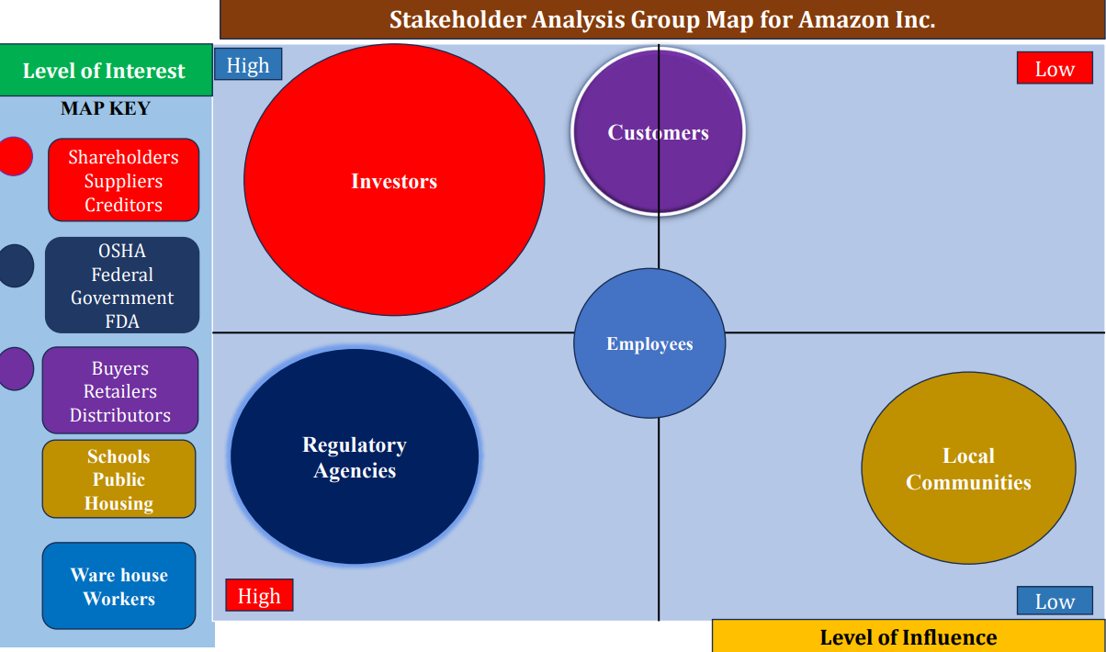
Fig 1: Amazon’s Stakeholders Analysis Group Map for the Problem (Napolitano, 2023).

APPENDIX II
AMAZON DECISION MATRIX TABLE
Solution Options | Criteria Weights | Improve Working Conditions |  | Revise Productivity Metrics |  | Increase Staffing Levels |  | Establish Worker Voice Mechanisms |  | Strengthen Safety Training
Criteria | Weight | 1-5 | Score | 1-5 | Score | 1-5 | Score | 1-5 | Score | 1-5 | Score
Effectiveness | 0.3 | 5 | 1.5 | 2 | 0.6 | 2 | 0.6 | 5 | 1.5 | 5 | 1.5
Cost | 0.2 | 4 | 0.8 | 4 | 0.8 | 5 | 1.0 | 4 | 0.8 | 4 | 0.8
Implementation Feasibility | 0.25 | 5 | 1.25 | 5 | 1.25 | 4 | 1.0 | 3 | 0.75 | 5 | 1.25
Stakeholder Impact | 0.25 | 3 | 0.75 | 5 | 0.75 | 3 | 0.75 | 2 | 0.5 | 3 | 0.75
Total Score | 1.00 |  | 4.30 |  | 3.40 |  | 3.35 |  | 3.55 |  | 4.30
Table 1: Decision Matrix Table for Amazon’s Problem (Sainato, 2023).
According to the decision matrix table, the most potent possible solution that Amazon should take is to improve working conditions and strengthen existing safety training measures and programs.

APPENDIX III
5 WHYS AND FISHBONE DIAGRAM FOR AMAZON ROOT CAUSE ANALYSIS
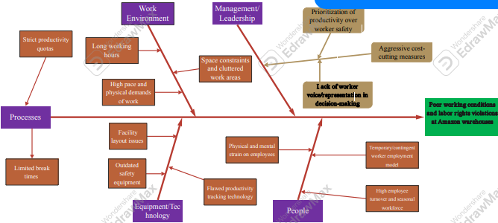
Fig 2: 5 Whys and Fish Bone Diagram for Amazon Root Cause Analysis (Edraw, 2024)
Key
Why -
Root Cause -
Problem Statement -

