Order form issues/amendments
- Once an individual navigates to the order section, it would be prudent the system to direct him/her to the order form and not the sign in page. As it is currently it directs one to the sign in page as opposed to the order form
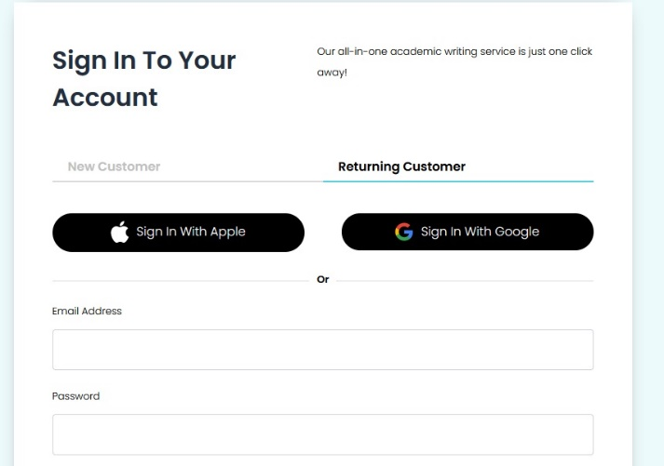
- The order form should have the back and next page navigation buttons at the bottom of the page to make it easier to move from one step of the order process to the next one. In addition, The system should have the ability to provide an order summary of the task at hand similar to edubirdie. The client may further amend/edit the order from this form similar to edubirdie. You may navigate to the edubirdie order page to view how it’s been done. https://edubirdie.com/order-writing/subject
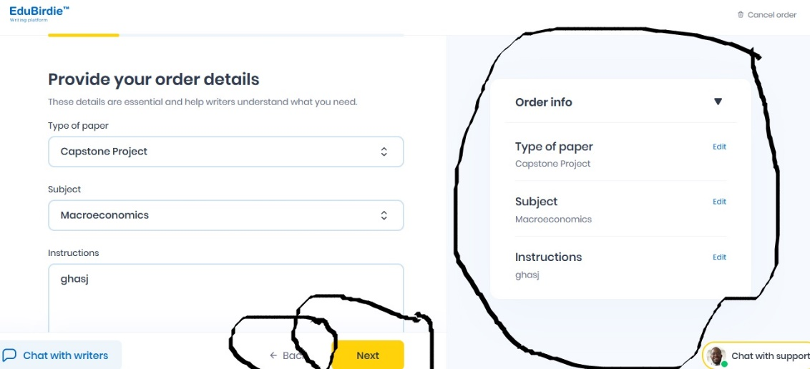
- On the third step of order customisation, one can have the ability to upload multiple files. As it is the user can only upload a single file. In addition, the client should be able to choose a specific date in a calendar
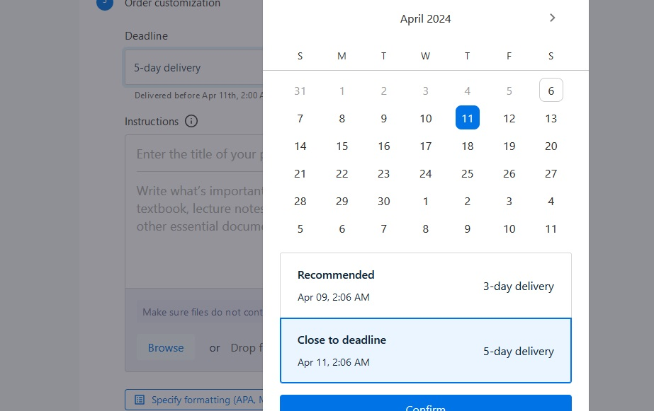
- I would like to clarify that single spaced is usually 550 words and double spaced is usually 275 words. For this reason, applying the single spaced option should automatically double the word count and reduce the number of pages. Kindly clarify this step with the order form at customwritings.com.
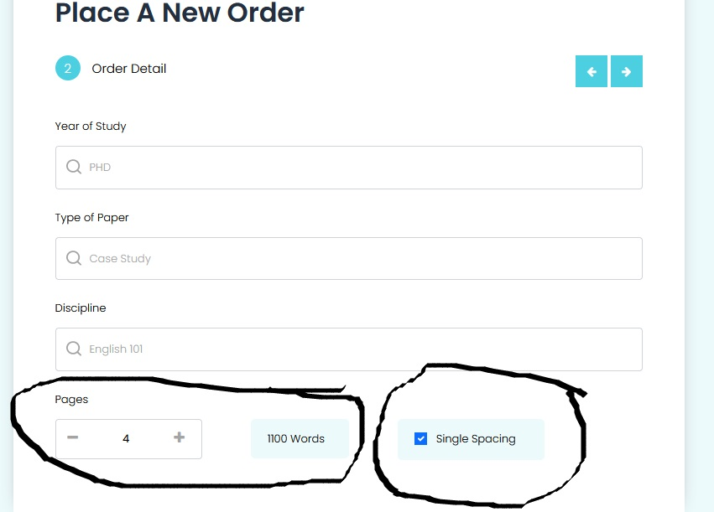
- On the third step of order customisation, kindly include the number of sources and paper format. Paper formats should include APA 6, APA 7, MLA 8, Chicago and other(here client can choose which format they need)
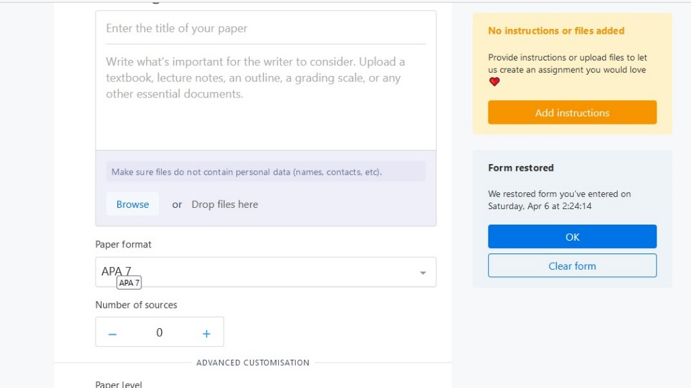
- For advanced customisation lets remove the printable sources and progressive delivery option as the goal is to make the order process as simple as possible
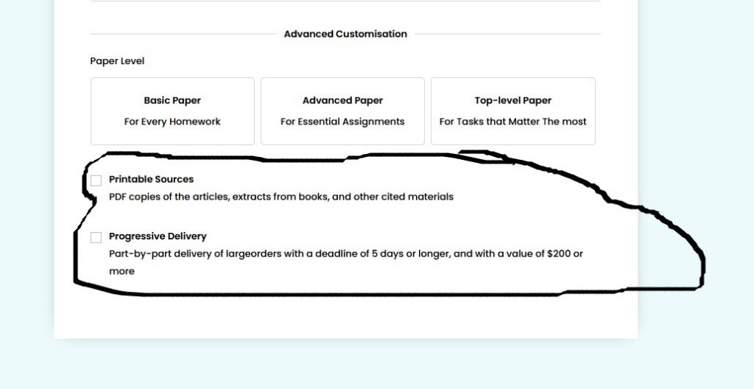

- In addition, the system should notify a user when they have not uploaded any files and/or instructions. This is a critical step of the order process as without instructions and files, the order cannot be done. In this step, the system should further have the ability to restore an order form since the last users attempt to place an order. This would come in handy in case the user’s device switches off or they erroneously move to another web page by mistake/intentionally and they need to continue with the order process.
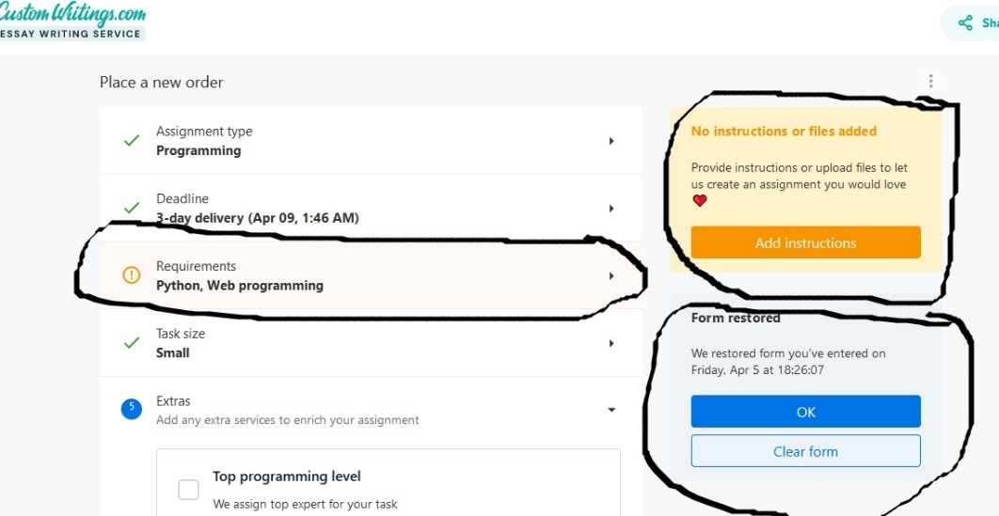

Kindly also check how the order process has been simplified by customwritings.com in such a way all the order details can be seen in a single page as opposed to navigating from one page to the next
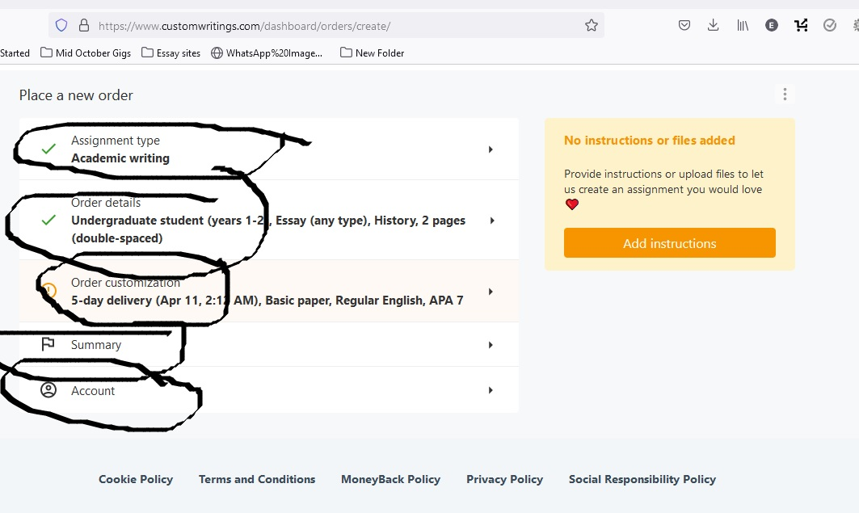

In addition, we will amend some content within the order form to avoid copyright issues. For instance as opposed to the first option being academic writing, we can name it research paper writing, In the third option, as opposed to calculations we can have it as arithmetic computations.
Within the third order in calculations section, discipline and software have been interchanged
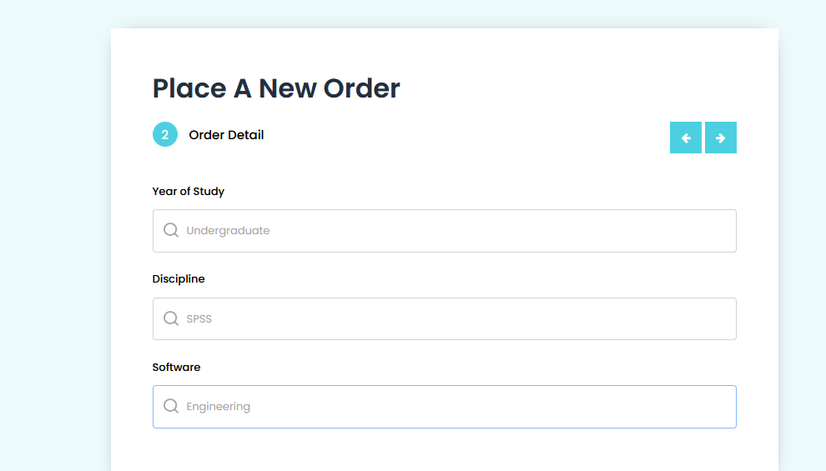

Client order dashboard issues/amendments
Here we want to make the order process as simple and smooth as possible requiring only an email address and password.
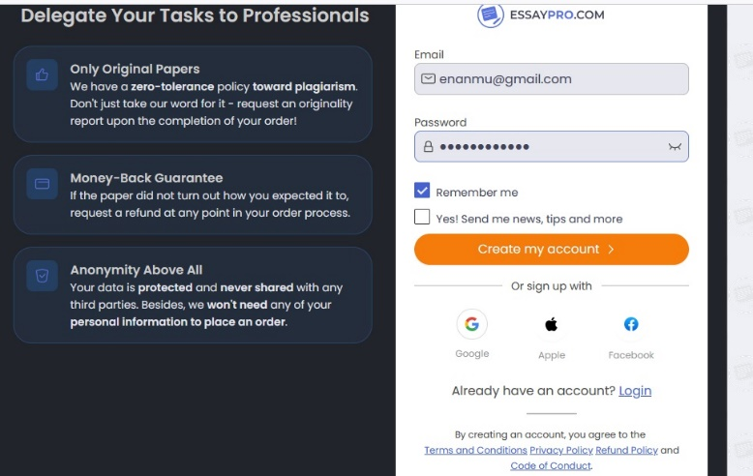
The password section should have the “eye” to easily view if the user has input the correct password
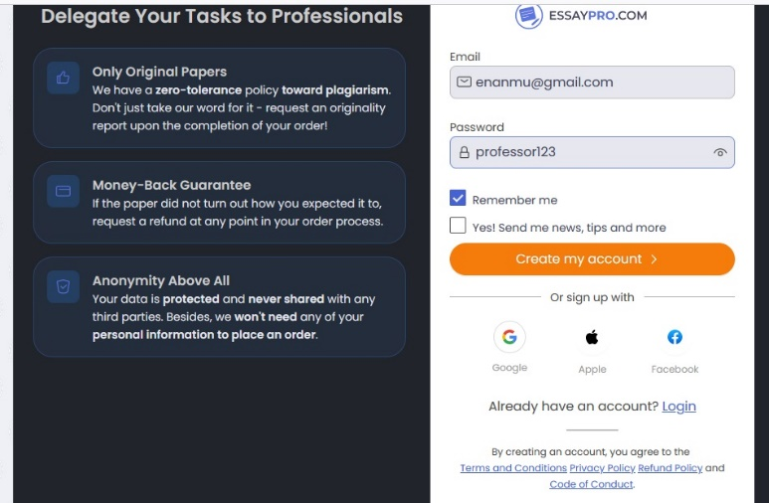

Once the client logs in, an email and activation button is sent to their email address as form of verification to open and use their account.
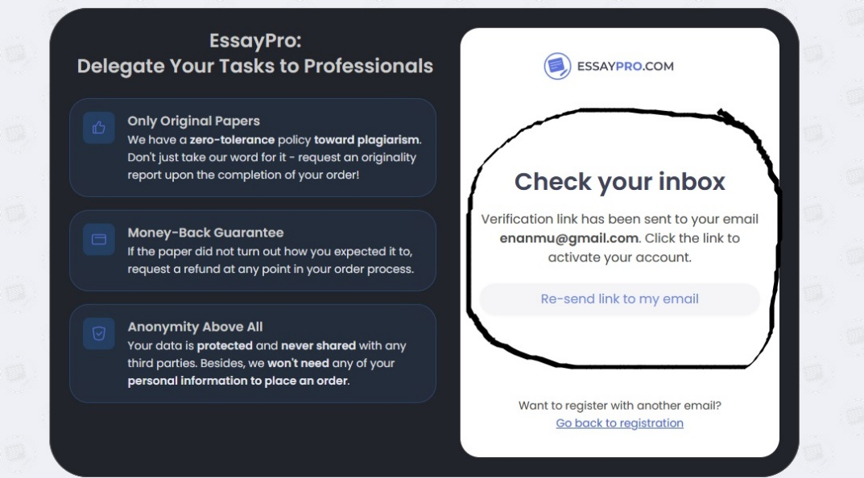
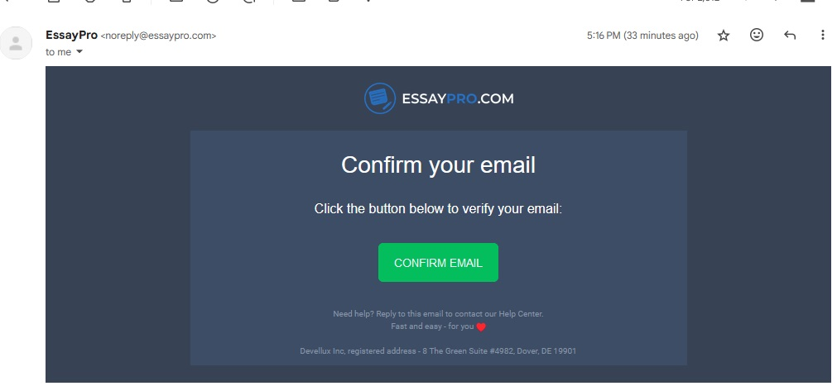
When a new client signs up in the system, the phone number should be optional. This improves the user capacity to identify any mismatch in passwords and make it easier for them to on board the system.
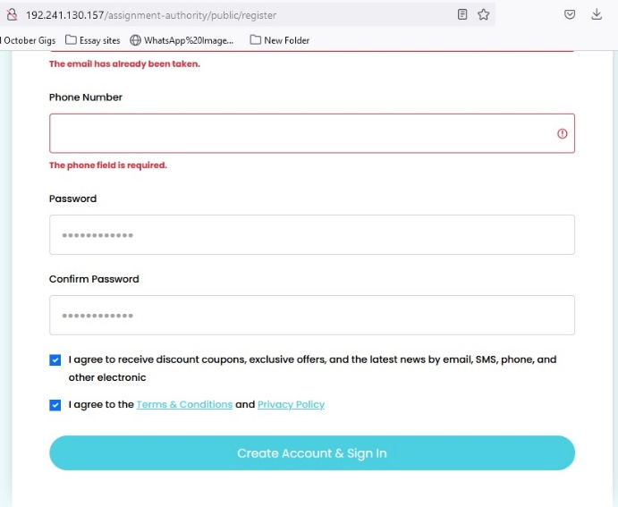
Once a new user opens an account they should receive a welcome notification. As it is, there is no welcome notification as one only receives an order summary in their email address once an order is placed. 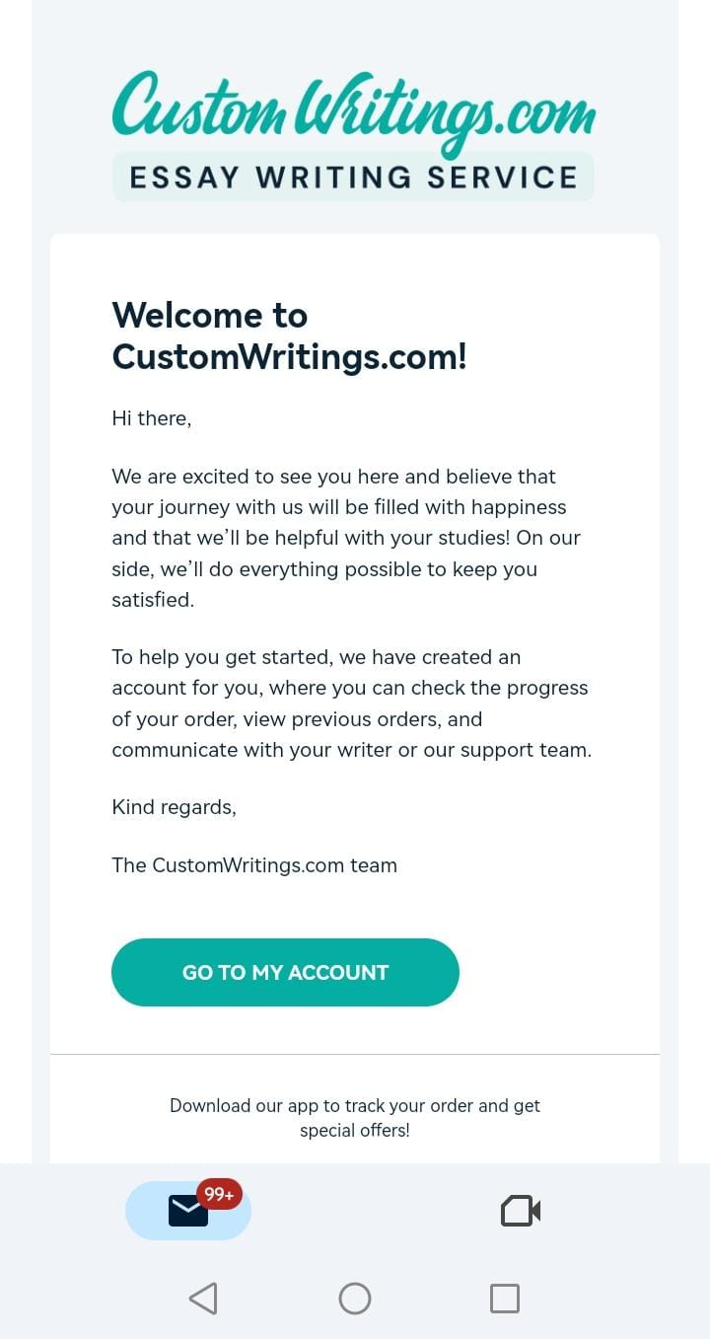

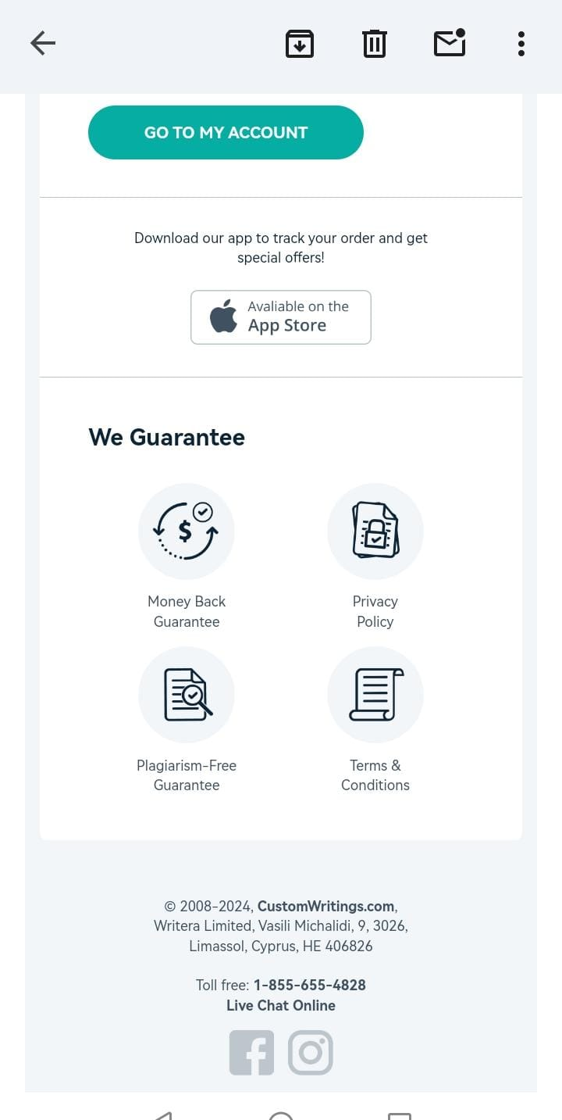
The section above should be combined with the authentication email link for sign up in such a way the user only receives one email with the welcome message and account activation via“confirm email”
Within my order section, order details should be placed in landscape mode to reduce clutter and easily view order details as per the clients request. The image below our page from edubirdie demonstrates an effective landscape layout.
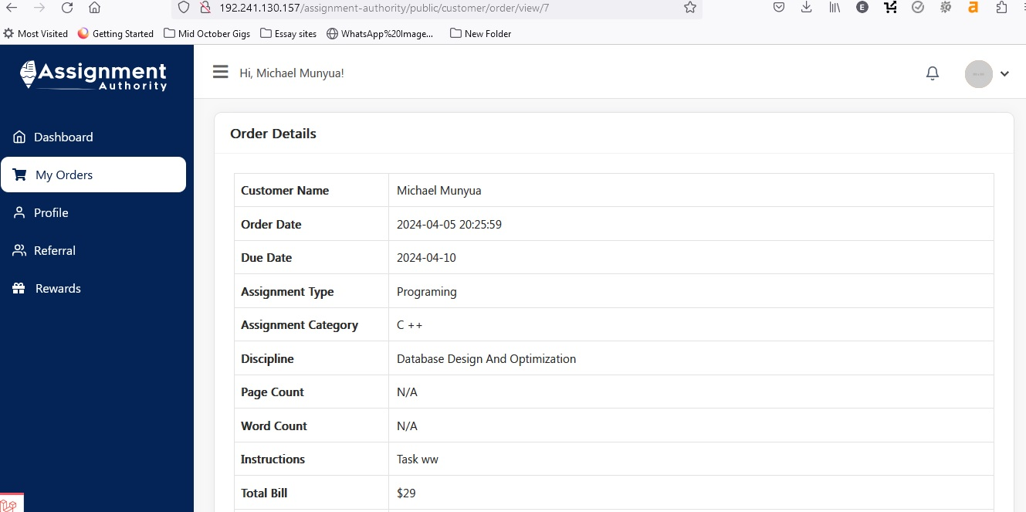
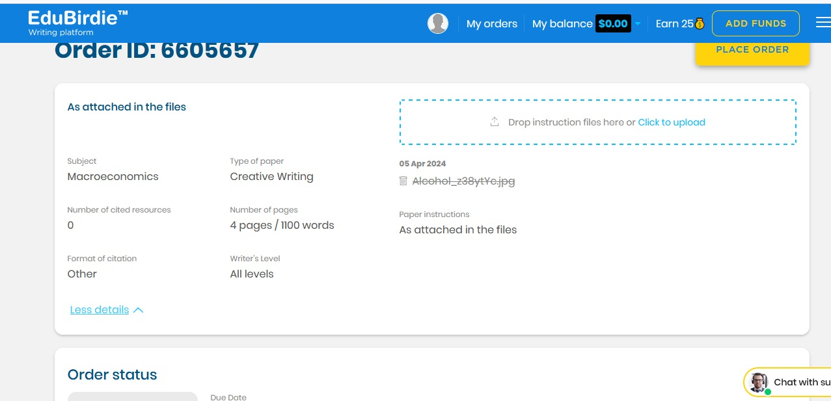
For the referral section, as opposed to having the copy button, we can have a share and copy button where one can share the link to whatsapp, messenger, snapchat, wechat telegram, facebook, mail, X, linkedin and finally the share link button. Customwritings.com and Youtube have got really nice share buttons
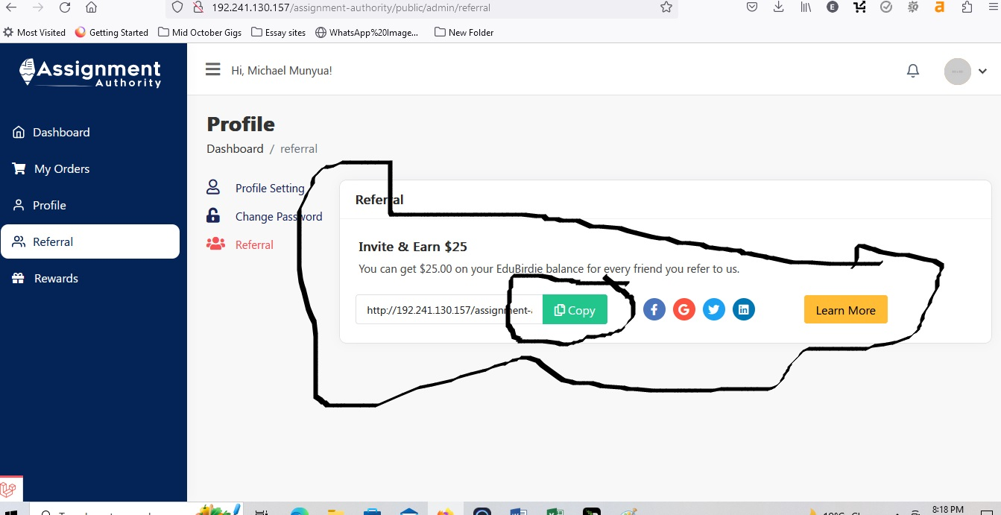
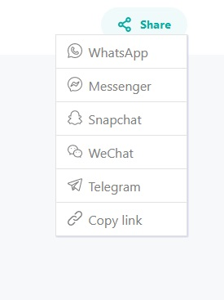
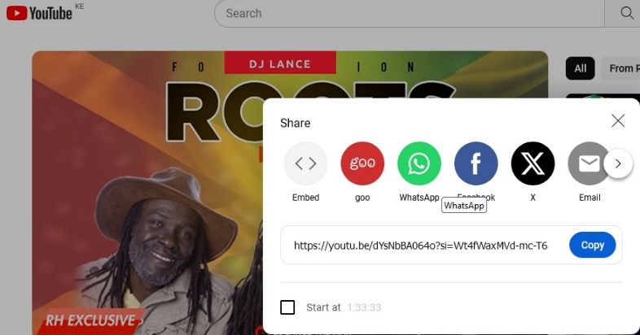
While placing an order, each order should have its own unique ID and a preceding email with the order requirements as a summary to the client’s email address. However, I have realised while placing the order, all emails have the same order ID AA-001, kindly check the attached images below.
